Case Study of Technology Usage by Selected NGOs and INGOs in Nepal  
Rupesh Ghimire, Romit Khanal, Kiran Maiya Prajapati, Pratiksha Shrestha, Shubham Joshi, Shiwani Adhikary,

*Kathmandu University, Dhulikhel, Kavre*

***Abstract****—***This document is a research paper based on the case study of the technology usage by selected NGOs and INGOs in Nepal to attain their sustainable goals. The idea was to collect the data of various technology used by different NGOs and INGOs in Nepal to attain their sustainable goals and research on how use of proper technology can make every day work easier and efficient in those organizations. As a result, we found out that the use of technology and number of persons in those organizations who are familiar with technology and innovations are increasing rapidly.**

Keywords*—* HCI, NGO, INGO, personnel

1. INTRODUCTION

Technology has always been the key point in the advancement of human society. Today, globalization has led to many advancements throughout the world, but still developing and remote countries face unique problems in attaining sustainability and development. With innovative products such as crop sensors, agro-bots and simulations for educational purpose, technology is providing better solutions for promoting sustainability and growth.

The aspect of usage of technology for development works is quite high in underdeveloped countries and also the most difficult to achieve. The main problem lies in the dismissive attitude of people towards utilizing tech related tools. [1] Lack of proper funds for technological education and research, lack of infrastructures and implementation are found to be the major obstacles in establishing IT as the major point in sustainable development.

The goal of this research was to determine how effectively the available technological sources are being used by the NGO’s and INGO’s in Nepal especially for the fulfillment of the sustainable development goals set by UN.

1. METHODOLOGY

We interviewed peoples from different NGOs, INGOs to collect the data and information. One persons per organization from five different organization were interviewed. We questioned them about the goals of their organization and the use of HCI in their organization. The questions were related methods the used in a particular project and how the project can be sustainable. The person we interview have worked in the particular organization for more than two years. The Interviews were conducted in two ways directly (face to face interview) and indirectly (through online forms). We recorded the interviews .We analyzed the data by hearing it and by the response we got from the online form and distributed the interviewed results among our group members

1. RESULTS

The research on various technological usages by various NGOs and INGOs in Nepal, concluded with the fact that though many organizations sought out for newer technologies, there were still some which tried to avoid them. As an example, below is a table showing the total percentage of Internet users in Nepal. From the chart, it is clear that most of the users are either commercial, home or international organizations. Only 15% of the total Internet Usage is by the NGO/INGOs. This clearly shows that there is still some organizations which hesitate to use new technologies.

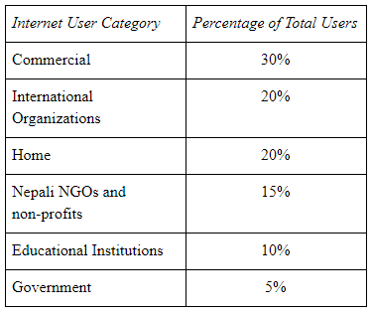

Source: Computer Association of Nepal, IT 2000 Millennium Souvenir

We interviewed some NGOs and INGOs personnel for our research. We consulted the following organizations:

* Rotaract Nepal
* Help Nepal
* WLiT Nepal
* Amnesty International

After some interviews and recording response of the personnel of various organizations, we were able to analyze the data and come up with some results. The major points we came to understand.

*A. Method of Attaining Project Goals:* The most common method of collecting data across the various organization was found to be top down approach. The higher chain of command gives instruction to the branch level on the protocols to follow. Regular collection of data was prioritized i.e. data collection was done on daily basis.

*B. Number of Personnel working with technology:*5 personnel in average worked with technology on daily basis on these organization. The data of the personnel working with technology on a daily basis is presented on the pie-chat below. Among these 75% were male and rest 25% were female.

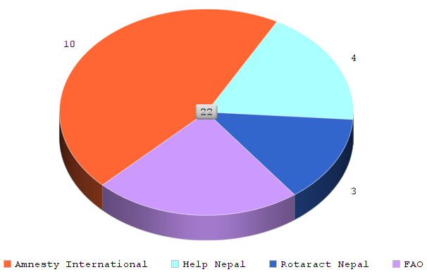

Figure 1:No. Of Personnel Working directly with technology on various organizations

*C. Challenges in developing technology:*In our country the major challenge of adopting technology is the obvious lack of necessary infrastructures. There is a lack of funding towards implementing technology. The government is just being concious in this matter. [2] “In a bid to promote entrepreneurship in the country, the government had announced a fund of Rs 500 million in fiscal budget 2015-16 and called on non-resident Nepalese, non-governmental organizations and the private sector to contribute to the fund.”

*D. Adapting New Technology:*

There were many challenging aspects about adapting new technologies, especially in the context of Nepal. The Nepalese people though some of being educated in computer related subjects, most of them are deprived of it. So when it comes to adopting new technologies, thee non-technical people had to be taught from the scratch. On the other hand, the technical people could easily catch up on new technologies.

*E. Training Methods:*

Many organizations were found to provide the necessary training programs to their employees, teachers and children. The trainings mainly included the people who were eligible to run the program that they are being trained for. The training methods mostly used were coaching and mentoring with few organizations using simulation software.

*F. Value of Technology:*

In the context of Nepal, the NGO/INGOs were moderately interested in newer technologies. Most of the organizations scored their value in the scale of 0 to 5, 0 being the least interested and 5 being extremely interested as 3.5 to 4. They factorized utilization of the new technologies as 0-1 and their use case of 4-3.

From our study, it is clear that the usage of technology in organization in context of Nepal is in its early stage. There are various challenges that have to be overcome to properly implement the use of technology in day to day activity of

IV.CONCLUSION

So we were able to ascertain some points from our study about the current situation on the usage of technology in organizations in Nepal and the challenges of introducing new technology to an organization. We also understood the HCI and its importance in meeting with the sustainable development goals.